**SPRINT2**

|  |  |
| --- | --- |
| Date | 13NOVEMBER 2022 |
| TeamID | PNT2022TMID17177 |
| ProjectName | Project – Smart Farmer-IoT Enabled smartFarmingApplication |

SensorConnection

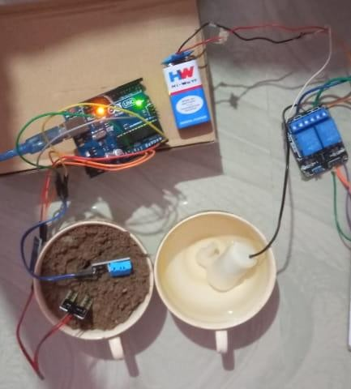

DeviceDetails:

